F R I D A Y 1 3 T H O F J A N U A R Y

ZEBROCK MUSICAL CONFERENCE

By Camille, Félicie, Ely and Alexandre

Friday 13th of January, we had the chance to attend the musical conference by ZebRock. It's an association offering several musical and cultural projects like Mélomanes! which invites high school students of Island of France to appropriate songs and other music of everyday in their historical, aesthetical, socials and cultural dimensions, all within in an original way and through meetings, workshops, conferences,…

highlighting a
Mélomanes!
proposes a full musical experience theme renewed each year. This year, the

subject focuses on « The body in all its states ». In fact,
music always had an important place in our lives, it is rhythmic by the heartbeats since our birth, that’s why music and body are linked. Mystic Gordon and Singe, two musicians committed in the association Zebrock, presented us this topic through songs dealing with exhaustion, suffering, effort, struggle, but also pride and acceptance of the body.

For instance, the song « Four Women » written in 1966 by Nina Simone, a jazz black American singer, report on the
oppression and racism suffered by 4 Afro-Americans women (Aunt Sarah, Saffronia, Sweet Things, Peaches) in the United-States during the segregation. In these 4 different personalities, she creates a genealogy of black women through slavery to the present. Throught these four characters who embody stereotypes, she describes her physical traits and the way she is seen and treated in society.

On the contrary, in the
INTERVIEW: Q&A WITH SINGE AND MYSTIC GORDON
-How many concerts have you performed since the beginning of your career ?
I lost count at some point, but maybe 600 ? It’s interesting to think about the difference between all those shows. Some have been in front of 2 (or zero) people, some in front of 1000. Sometimes backstage was the garbage room, sometimes I was in a Zenith...

-Why did you choose this theme dealing with the ‘body’ ?
Without body, no music, because music is born from movement. Without body, no emotion too ! Our body should not be cut off our minds, they’re actually the same thing.
It’s also interesting to question how hatred can use bodies to draw lines between people. That’s why we talk so much about racism and misogyny.

-Why did you choose these artists to represent your theme ?
Zebrock did, not us, but we think it’s perfect : there’s a good balance between American and French, old and new ! There are no artists from other parts of the world like South America, West Indies, Africa, Asia, sadly, but at some point you have to make a choice – and you also have to be able as a musician to play the songs right and that wouldn’t have been easy with these kind of music.

song
«Vogue»

Madonna,
from 1990, an iconic

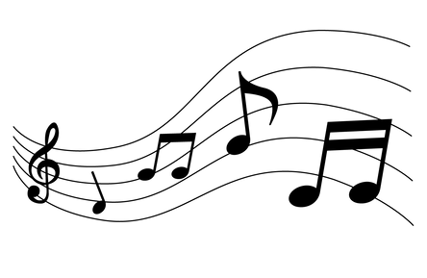
American singer in the 1980/90s, celebrates confidence, sexiness and pride of the body namely through voguing, a dance performed in New York's gay nightlife since the 1970s, itself inspired by the poses of the models in the famous fashion magazine of the same name.

As far as I'm concerned, I enjoyed this conference because having outside speakers brings something new and different from what we are used to do in class. Thus we were able to discover songs, artists and an important theme to address in our society. I believe we are lucky to be part of this project and we look forward to continuing it.

