Melomanes!!

Thursday, we attended a conferance organized by a project Melomanes. It's a musical project that proposes a musical experience for all high school students in Ile-de-France.

Last Thursday two artists from ZebRock, named Singe and Mystic covered several songs at the request of the association dating from the 60s to the 2000s. They explained the story behind the music after their interpretation. For their show, they used theclassical guitar, electric guitar, and their voices. The conference was focused on one main theme.

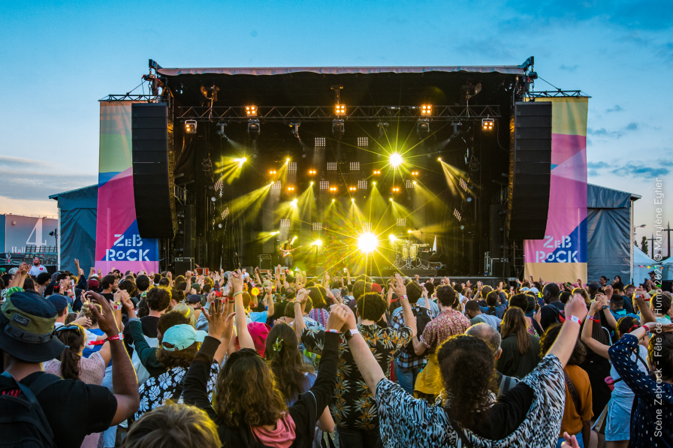
Indeed, the theme was "the body in all its states". We learned the body is linked with music and sound because heartbeats are the first sound a child hears, Since the beginning of humanity, their singing music to convey an emotion through music, tell a story or celebrate an event.

Each song was either covered by Singe or Mystic.
At the beginning, the song was concentrated on the violence against Afro-American people. Actually it was about racial discrimination, segregation and with the most dangerous associations of people such as the Klux Klux Klan. But, fortunately the famous, Martin Luther King struggled against segregation. But many other singers like Nina Simone who was a descendant of slaves wrote a song in 1966 « Four Women » about oppression suffered by Afro-American women.
.
Then, they spoke about work competition, or what society expected from some women or men with « Vogue » written by a famous artist, like Madonna or « Rehab » by Amy Winehouse.
Finally they performed a poignant song written by Yseult, in 2019 which is about self-acceptance in dark times due to terrorist attacks, Brexit etc.

Now let’s interview Singe and Mystic Gordon:

-When did you start this job as a musician, singer and producer ? What does it mean to be a musician to you ?
As a musician, there’s rarely an on/off switch as far as making a living goes. That’s how it went for me, at least. It was maybe in 2015 or 2016 that I really started playing outside of my bedroom : first for free at open mics in bars in Paris, or in the subway (by the way, you need an authorization, otherwise you’ll get fined, like I did haha), then organizing little shows in bars for just a few euros or even for free ; and then at some points you start to get better-paid opportunities, and getting them more often. I’ve been able to support myself as a musician from 2019 I think.

-Do you only play the guitar, the electric guitar or can you play other instruments ? What is your favorite one(s) ?
Singing and guitar are my main instruments. I can make a sound out of pretty much anything else, but that doesn’t mean I could work as a player of those instruments in a professional context. But what’s cool about art is that it’s all about being creative : and when I produce a track, I can have fun making sounds with stuff even if it’s not the standard way of playing it.

-Singe, when did you start producing songs ? What does it mean to you to sing in front of everyone or for everyone ?
It came pretty late in my musical development, in 2021. It’s a really different process from playing on stage, even though you can link them by thinking about how it’s gonna do on stage while producing or thinking about what you wanted to achieve at the production stage when you tackle the live arrangement.
Singing on the stage : it’s my calling in life, the only place I really feel I belong. It’s a magical time and space that can bring every single individualities in the room to feel lighter and happier for a few moments.

Joana, Coline, Damien, Johan

